GRUPA MOTYLKI Środki lokomocji
15.06.2020- 19.06.2020

-Hello boys and girls!!! [heloł bojs ent gerls] - witajcie chłopcy i dziewczynki

How are you today? [hał ar ju tudej?] - jak się dzisiaj masz / macie?

-I’m fine, thank you. [ajm fajn fenk ju] – czuję dobrze, dziękuję

-Listen to few songs. [lysyn tu fju songs] – posłuchaj kilku piosenek

Przypomnij sobie nagranie z zeszłego tygodnia.

Bugs | Teacher's Video
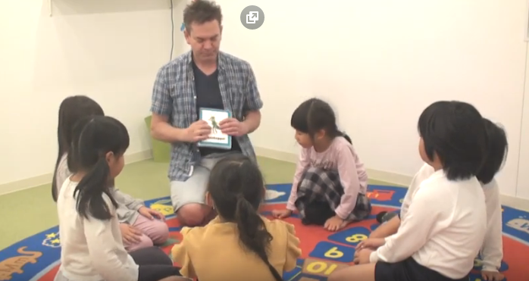

https://www.youtube.com/watch?v=mEh6Xv06wK4
"Bugs" Song Lyrics:
Bugs! Do you like bugs? [bags, du ju lajk bags?] – robaki, lubisz robaki?
Bugs! Do you like bugs? [bags, du ju lajk bags?] – robaki, lubisz robaki?
Grasshopper, grasshopper, grasshopper! [grasshopper] – konik polny
Ant, ant, ant! [ant] - mrówka
Caterpillar, caterpillar, caterpillar! [katepilar] - gąsienica
Bee, bee, bee, bee! [bi] - pszczoła
Bugs! Do you like bugs? [bags, du ju lajk bags?] – robaki, lubisz robaki?
Bugs! Do you like bugs? [bags, du ju lajk bags?] – robaki, lubisz robaki?
Beetle, beetle, beetle! [bitl] - chrząszcz
Dragonfly, dragonfly, dragonfly! [dżragonflaj] - ważka
Worm, worm, worm! [łorm] - robak
Mosquito, mosquito, mosquito, mosquito! [moskitoł] - komar
Bugs! [bags] – robaki

Let’s play –zabawmy się
Hop like a grasshopper [hop lajk e grasshopper] – podskakuj jak konik polny
March like an ant [marcz lajk an ant] – maszeruj jak mrówka
Crowl like a caterpillar [krołl lajk e katerpilar] – czołgaj się jak gąsienica
Fly like a bee [flaj lajk e bi] – lataj jak pszczoła

Learn Vehicles | Guessing Game for Kids

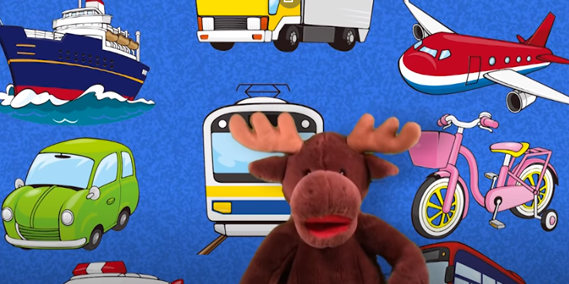
https://www.youtube.com/watch?v=QxoqW84ec-M

What is it? [łot ys yt] – co to jest?
It's a car. [yts e kar] – to jest samochód
What is it? [łot ys yt] – co to jest?
It's a bus. [yts e bas] – to jest autobus
What is it? [łot ys yt] – co to jest?
It's a train. [yts e czrejn] – to jest pociąg
What is it? [łot ys yt] – co to jest?
It's a ship. [yts e szip] – to jest statek
What is it? [łot ys yt] – co to jest?
It's an airplane. [yts an erplejn] – to jest samolot
What is it? [łot ys yt] – co to jest?
It's a bicycle. [yts e bajsykl] – to jest rower
What is it? [łot ys yt] – co to jest?
It's a helicopter. [yts e helikotper] – to jest helikoper
What is it? [łot ys yt] – co to jest?
It's a truck. [yts e czrak] – to jest samochód ciężarowy
What is it? [łot ys yt] – co to jest?
It's a fire engine. [yts e fajer endżin] – to jest wóz strażacki
What is it? [łot ys yt] – co to jest?
It's an ambulance. [yts an ambjulans] – to jest karetka
Hey, what's that? [hej łot ys tat] – hej, co to jest?
That's not a vehicle. [dats not e wajakl] – to nie jest pojazd
It's a frog! [yts e frog] – to żaba

Bye Bye Goodbye | Goodbye Song for Kids | Super Simple Songs
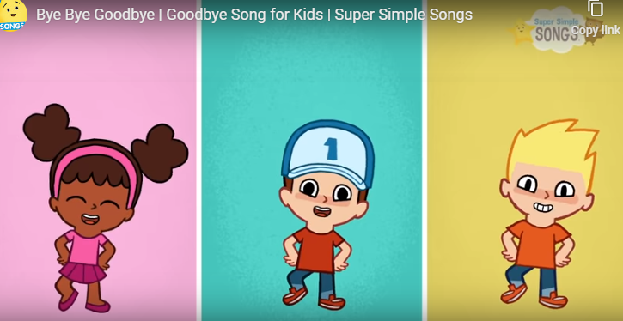
https://www.youtube.com/watch?v=PraN5ZoSjiY

Bye bye. Goodbye.[baj baj, gudbaj] – pa pa, do widzenia
Bye, bye, bye, bye. Goodbye. [baj baj baj baj gudbaj] – pa pa pa pa do widzenia
I can clap my hands. [aj ken klap maj hends] – potrafię zaklaskać moimi rękami
I can stamp my feet. [aj ken stomp maj fit] – potrafię zatupać moimi nogami
I can clap my hands. [aj ken klap maj hends] – potrafię zaklaskać moimi rękami
I can stamp my feet. [aj ken stomp maj fit] – potrafię zatupać moimi nogami
Bye bye. Goodbye. [baj baj, gudbaj] – pa pa, do widzenia
Bye, bye, bye, bye. Goodbye. [baj baj baj baj gudbaj] – pa pa pa pa do widzenia
Bye bye. Goodbye. [baj baj, gudbaj] – pa pa, do widzenia
Bye, bye, bye, bye. Goodbye. [baj baj baj baj gudbaj] – pa pa pa pa do widzenia

Have fun! [hew fan] – baw się dobrze!
Goodbye [gudbaj] –do widzenia

